Year 10
OLNA class

Test 1

2018

Time


Name: ______________________ Class: ______ Time: 15 minutes (strict) Total Mark:____/11

Resources: No calculator allowed

Question 1 3 marks

Use the calendar below to answer the following questions:
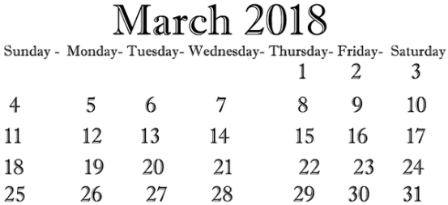
a) | $$Sunday, the 4th, to Monday the 5th, represents what fraction of the second week?$$
 | A $\frac{4}{7}$ | B $\frac{2}{7}$ | C $\frac{2}{31}$ | D $\frac{2}{5}$
b) | $$Tuesday, the 20th, to Sunday the 25th, represents what fraction of the month?$$
 | A $\frac{5}{31}$ | B $\frac{6}{31}$ | C $\frac{4}{31}$ | C $\frac{4}{30}$
c) | What is the date a fortnight before the third Thursday in March, 2018?

Question 2 1 mark

What is the time, eighty-three minutes before 12:12am?
A $1:35 pm$ | B 11:29 pm | C $10:35 pm$ | C $10:49 pm$

Question 3 1 mark

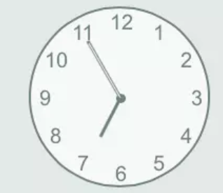 | A Five to seven | B Five past seven | C 7:55 | D 50 minutes past 6
Question 4 3 marks

Toby is about to take off on a flight and observes the list of departures shown below. Use this table to answer the following questions.
Destination | Airline | Flight | Time | Status | Gate
Gold Coast | JetWing | JW422 | 9:34am | On Time | A2
Sydney | GreenAir | GA123 | 9:50am | On TIme | G1
Newcastle | GreenAir | GA453 | 10:00am | Delayed | G6
Adelaide | JetWing | JW895 | 10:05am | On TIme | A1
Canberra | JetWng | JW555 | 10:25am | On TIme | G3
Darwin | GreenAir | GA922 | 10:35am | On TIme | G5
Melbourne | JetWing | JW866 | 10:50am | Delayed | A2

a) | If Josh reads the departures board at 8:49am, how much time is there before the scheduled flight to the Gold Coast departs?
 | A $43 minutes$ | B 85$minutes$ | C 37$minutes$ | D $45 minutes$
b) | If the plane to Melbourne is delayed a further 84 minutes, what will be the new departure time?
 | A $11:34am$ | B $12:14pm$ | C $11:54am$ | D $12:24pm$
c) | JetWing flies to the Gold Coast every 150 minutes. When is the last flight on the day, given that it does not fly later than 8:00pm?
 | A 6$:34pm$ | B 6$:04pm$ | C 7$:34pm$ | D 7$:04pm$

Question 5 1 mark

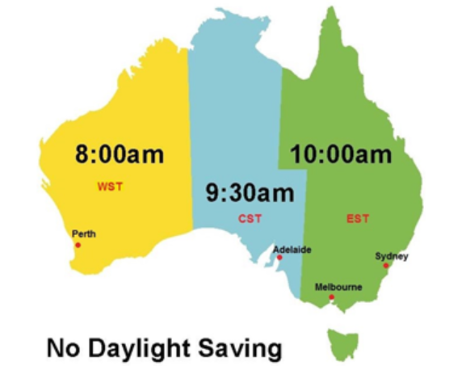
Use this knowledge of Australian time zones during non-daylight saving periods to state the time in Sydney if it is 15 minutes past 11 on Friday night in Perth.
A 15 minutes before 1 on Saturday morning | B 15 minutes pass 1 on Saturday morning | C 15 minutes pass midnight | C 15 minutes before midnight

Question 6 1 mark

Anne and Kate are flying to Europe on holidays. Anne is flying to Dubai and Kate is flying to Berlin. How long after waving goodbye to Anne does Kate have to wait before boarding her flight to Berlin?

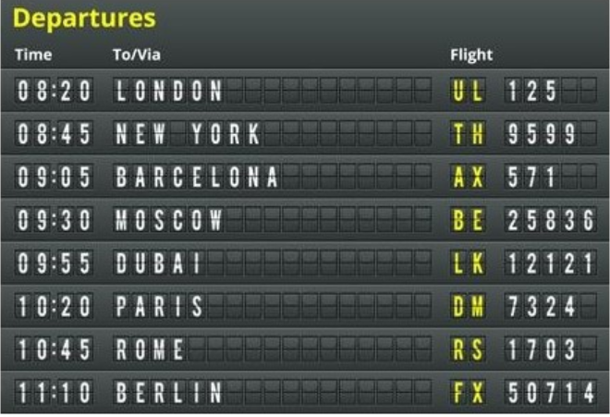

A 65 minutes | B 7$5 minutes$ | C 10$5 minutes$ | D 12$5 minutes$

Question 7 1 mark

The clock below shows the time that a bus departs at Cockburn Bus Terminal. If the bus takes a thirty-eight-minute journey, when would it arrive at its destination?

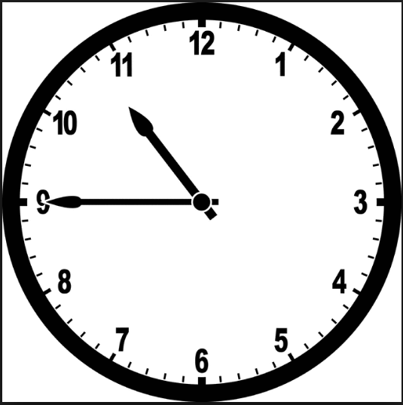

A 11:13 | B 11:23 | C 11:33 | D 11:18

END OF TEST

